1. Introduction
This project is a Spam Detection System that classifies text messages as Spam or Not Spam using Machine Learning.

2. Objective
To build a system that detects spam messages using different machine learning models and compares their performance.

3. Goal
The goal is to improve text classification accuracy and provide an easy-to-use interface for testing messages.

4. Dataset
A dataset (spam.csv) containing labeled SMS messages (spam/ham) is used for training and testing.

5. Preprocessing
Text is cleaned by removing links, special characters, numbers, and converting it to lowercase.

6. Models Used
Five machine learning models are used:
- Naive Bayes
- Logistic Regression
- SVM
- Random Forest
- Decision Tree

7. Feature Extraction
Text is converted into numerical form using TF-IDF and Bag of Words techniques.

8. GUI
A Tkinter-based GUI is used which includes:
- Text box for input message
- Process button
- Five output labels showing predictions from each model (Spam / Not Spam)

9. Conclusion
The system successfully classifies spam messages and compares different machine learning models to select the best performance.

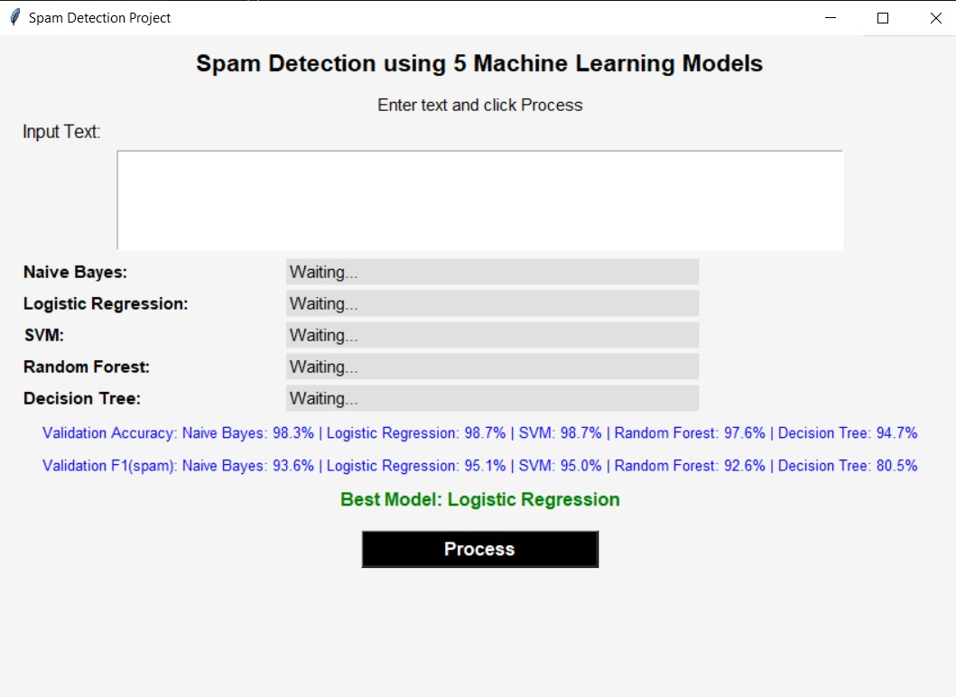

The Spam Detection System is a GUI-based application that classifies text messages as spam or not spam using five machine learning models: Naive Bayes, Logistic Regression, SVM, Random Forest, and Decision Tree. Users input text, click the Process button, and receive predictions from each model.
The system also displays performance metrics, where Logistic Regression and SVM achieve the highest accuracy (98.7%) and strong F1 scores (~95%), making Logistic Regression the best overall model. Decision Tree performs the weakest, especially in detecting spam.
By comparing multiple models, the system ensures reliable classification and provides insight into model performance. It is simple to use and can be further improved with features like confidence scores, better UI visualization, and model customization.
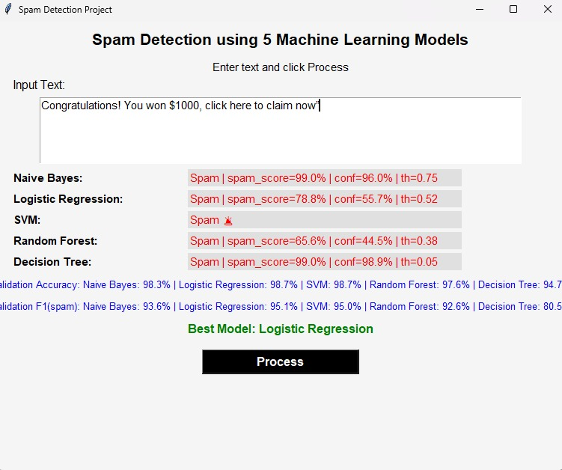

- The input message “Congratulations! You won $1000, click here to claim now” was tested.
- All five models (Naive Bayes, Logistic Regression, SVM, Random Forest, Decision Tree) classified it as Spam.
- Naive Bayes and Decision Tree showed the highest confidence (~99%), while Logistic Regression showed moderate confidence (~56%).
- Despite variations in confidence, all models agreed, confirming a strong spam prediction.
- Based on overall performance, Logistic Regression is identified as the best model.
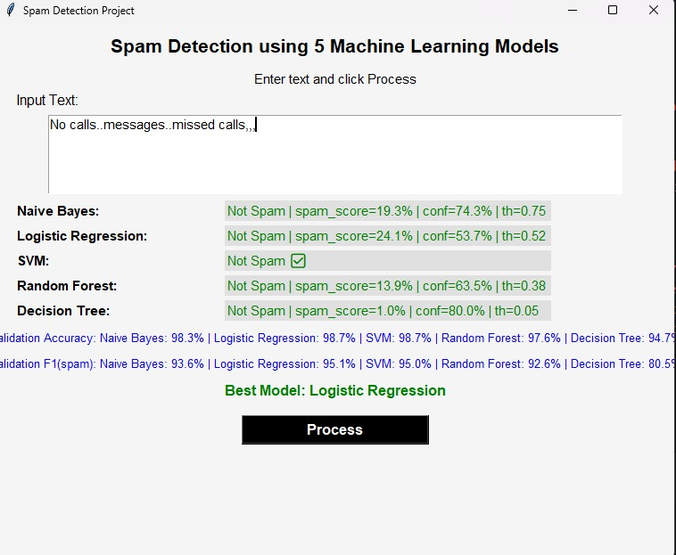

- The input message “No calls..messages..missed calls,,,” was tested.
- All five models (Naive Bayes, Logistic Regression, SVM, Random Forest, Decision Tree) classified it as Not Spam.
- Spam scores were low across all models (as low as 1.0%), confirming it is a safe message.
- Decision Tree and Naive Bayes showed higher confidence, while Logistic Regression showed moderate confidence.
- Overall, the models agreed completely, ensuring a reliable classification, with Logistic Regression as the best overall model.

